- How to check number line, word count and size of file?
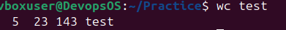
- How to check user in system?
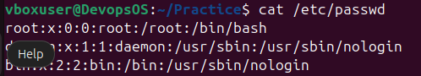
- How to read file?
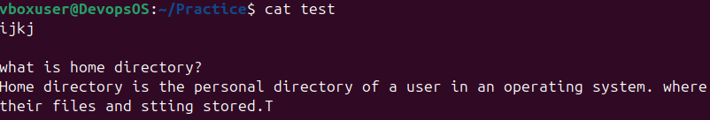
- How to create User?
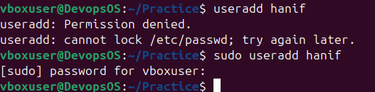
- How to check user is created or not?

- To update user password?
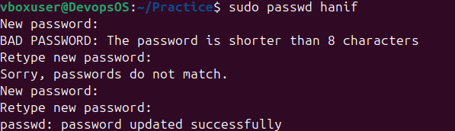
- How switch user?
- How to check currently in which user?
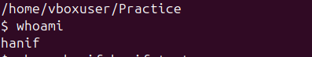
- How to check particular user’s group?
- How to check all user’s group?
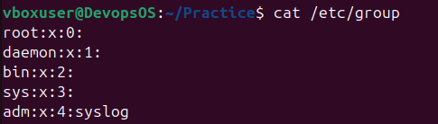
- Assignee Read Write execute permission?
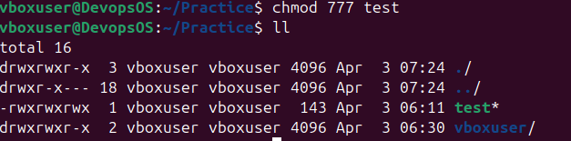
- How to give sudoers access to hanif user?
- How to find sudoers file?
- How to open /etc/sudoers file?
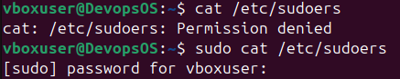
- Open this file in editor?
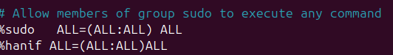
- How to display message?
- How to create file with hello world and create new file with hello name?
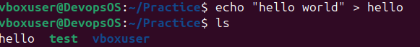
- How to see file?
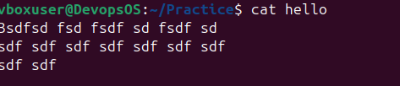
- How to see head 4 line ?
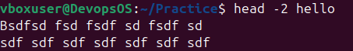
- How to see last 4 line?
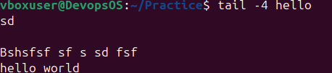
- How to find .txt all file in system?
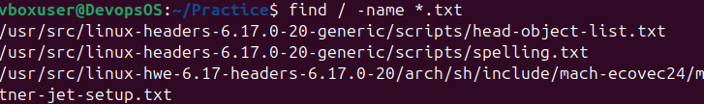
- How to find world in hello file?
